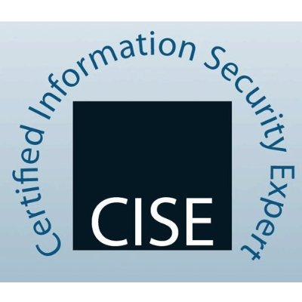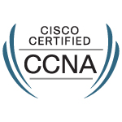

Tejas R Patwari

C-501, Shri Guru-Ganesh Nagar, Katraj - Kondhwa road, Near Indian oil petrol pump Pune, Maharashtra India 411046

+91 8408014488
tejaspatwari@gmail.com
Passport No: L4659023

jOB sUMMARY

- A Computer Engineering graduate having more 26 Months of Experience in the field of Networking and Network Security; involved in Installation & Commissioning, Operation and Maintenance, Troubleshooting of computer network, security and network devices like Routers, Switches, VPNs, Firewalls, Storage, load balancer, high-speed links in LAN/WAN environment and Virtual Private Network.

Technical Skill Set

- Routing Protocols: OSPF, BGP, EIGRP, RIP
- Switching Technologies: VLANs, STP, RSTP, Inter-VLAN, VTP.
- Other Technologolies : FTP,IPS, DNS, SNMP, bind, ssh, HTTP/HTTPS, LDAP, Radius, IPS/IDS, Unified Threat Management
- Protocol Suites: TCP/IP, OSI model, IPSEC, ARP, ICMP and other protocols.
- VPN : Site to site VPN(Point to point using IPSec) ,RAVPN, and SSL VPN.
- Cisco Routers: 3800, 2821, 2921, 2600 Series.
- Juniper : Screen OS Firewall, JUNOS(Router).
- Firewall : Cisco ASA 5505, 5520,Juniper ScreenOs, Watchguard M300.
- Virtualization: KVM, xen, libvirt, qemu.
- Proteus from IBM: Managing address space and DNS/DHCP core network services.
- ProxySG appliances from Blue Coat: Provides control over web traffic and is part of Unified Security Solution.
- Ticketing Tools : Service Now, Cherwell and Altiris.

Professional CRTIFICATION

CCNA CSCO12339776u
CCNA Security

CISE 29825

Professional Experience

Arcelia IT Services.
(July 2013 – Present)

Customer Sites- British Telecom, Uniquest Infraventures, Syngenta India, BMW.

JOB PROFILE:

- Install, support and maintain firewall and other security hardware and software infrastructure according to industry best practices, including firewalls, intrusion detection and prevention devices, and VPN concentrators
- Deployed and supported the production routers, switches, routers, load balancers, Intrusion Prevention Systems and firewalls.
- Designed, implemented, and managed complex networks, systems and configurations in a multi-site environment.
- Migrated VPN Tunnels from Checkpoint to New Cisco ASA and Palo Alto firewalls.
- Managed Checkpoint Firewalls from the command line (cpconfig and Sysconfig).
- Implemented the migrated policies from Checkpoint R60 to Cisco ASA 8.6.
- On firewall Cisco ASA, authorizing and authenticating access, modifying (allowing and blocking) access as per customer approvals and maintaining the firewall.
- On Juniper Firewall, Configuration, maintenance and troubleshooting related to zones, policies, filters, screens, class users and also backup and rollbacks.
- Configuring VPN tunnels, allowing access to VPN and trouble issues related to VPN.
- Implementing Site to Site VPNs and troubleshooting VPNs between multivendor firewall and VPN Concentrators
- Create documentation in the form of Case notes, RCA, KB articles, Best practices guide on the complex cases and share this with the Escalation/Support team members
- Configuring Cisco Wireless AP, allowing access, maintaining and troubleshooting issues, using Cisco wireless controllers for managing.
- Troubleshooting by analyzing packet on Wire shark, logs and debugs.
- Monitoring & troubleshooting the LAN & WAN.
- Configuration of routing protocols- RIP, EIGRP and OSPF, BGP.
- Configuration of VLAN, Inter VLAN communication in Layer2 & Layer 3 Switches.
- Cisco IOS backup & uploading. Maintaining IP data sheets, Monitoring, taking backup for daily, weekly, monthly basis.
- Install, configure and maintain network services, equipment and devices.
- Maintaining and Updating the Network monitoring tool e.g. adding the devices to the servers and server to the tool.
- Using monitoring tool for manually checking the status of devices.
- Restoration and backup for Cisco IOS from servers.
- Performs routine network maintenance and health check for network servers, routers and Switches.
- Maintaining WAN infrastructure consisting of leased line and dedicated Internet connectivity.

Educational Qualifications

MIT-COE Pune, Maharashtra India | 2008 - 2013
B.E Computers, AGG: 60.00
Keshavraj Vidyalaya Latur, Maharashtra India | 2004 - 2005
S.S.C, AGG: 84.53
S.P.College Pune India | 2006 - 2007
H.S.C, Group AGG: 78.00

Personal skills and Hobbies

- Easily co-ordinate with team members.
- Ability to upgrade latest technology.
- Motivating team & willing to work hard.
- Flexible Manageable, adaptable, and versatile.
- Good Logical thinking & reasoning.
- Sports enthusiast, I have been part of various Cricket and Basketball events at Corporate level.

Personal Particulars

Father Name: RATNAKAR KULKARNI
Date of birth: 19/05/1990
Languages Known: English, Hindi, Marathi
Marital Status: Single
Nationality: Indian

I hereby declare that the above information furnished is true to the best of my knowledge.

Tejas Patwari

